FACEBOOK

First we will create two variables to store user’s email and password

Then we will open facebook.com on a browser

Then we will sign-in by clicking login button-

* search u_0_b by id

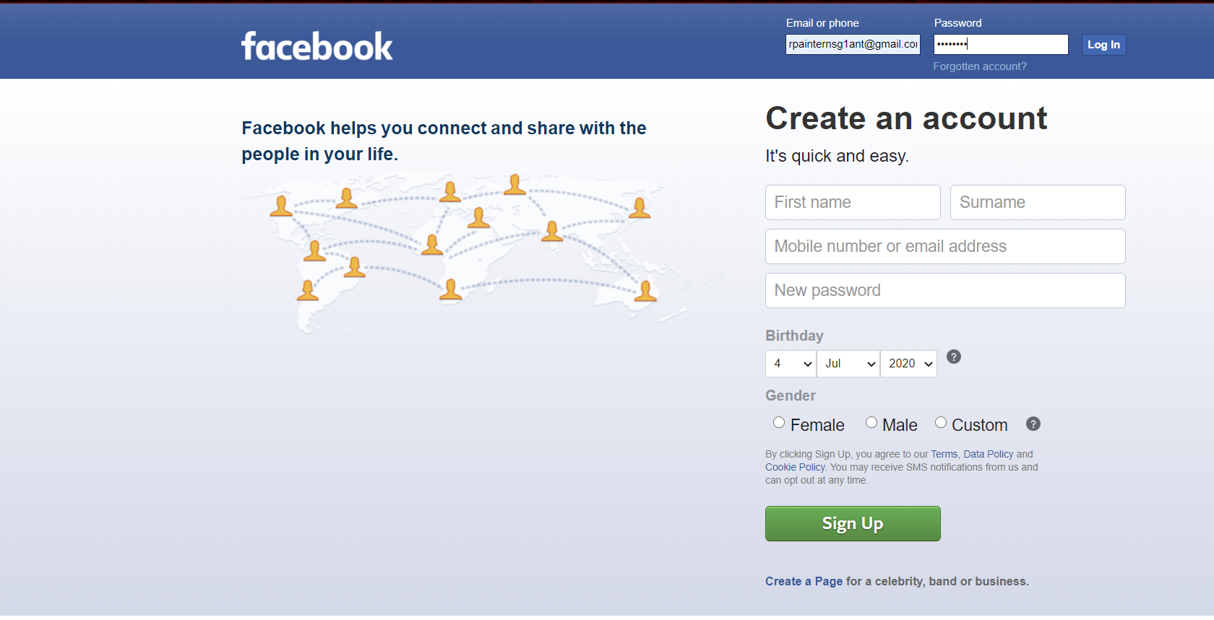

* We can create post by typing using xhpc_message by name and then clicking Post button using _45wg _69yt by class

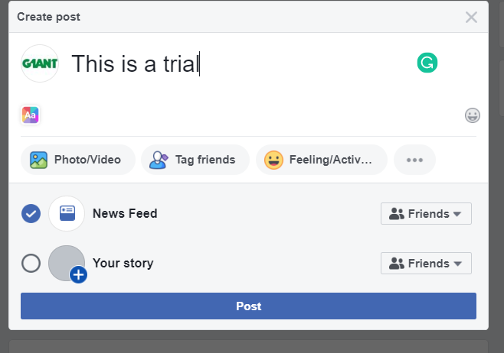

* We can find friends by typing in search bar using search q by name and then Enter it and then by identifying it user can send friend’s request to it.

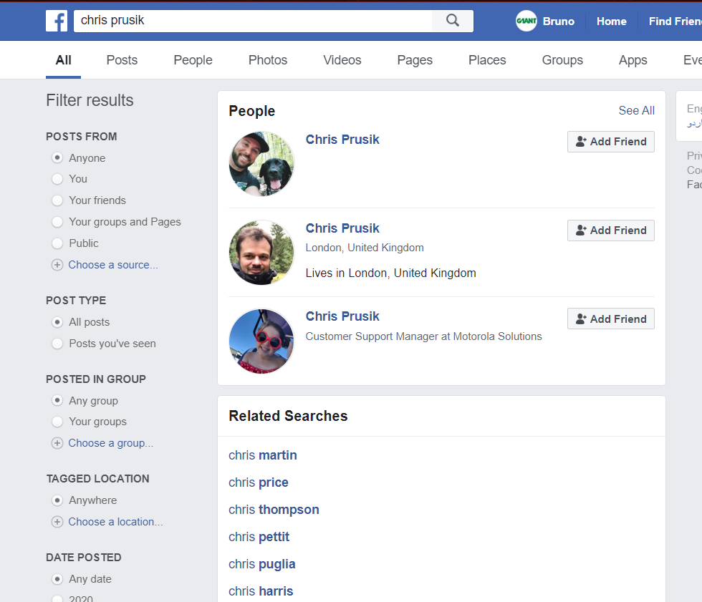

* We can like the latest post on our Newsfeed using _8c74 by class.

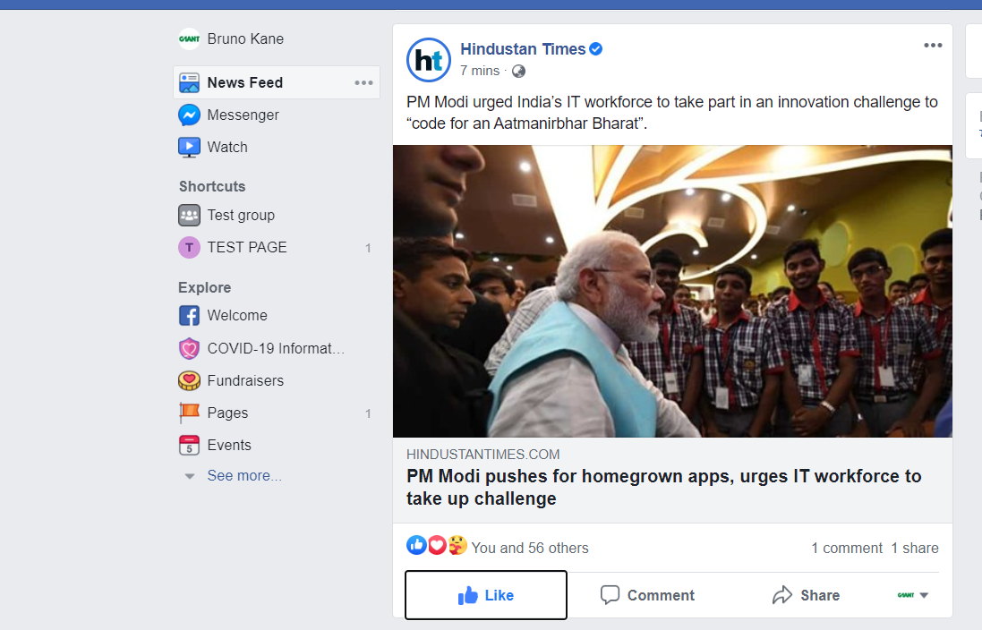

* We can create a group/page with a desired name using creation_hub_entrypoint by id and then click option of group or post using their classes

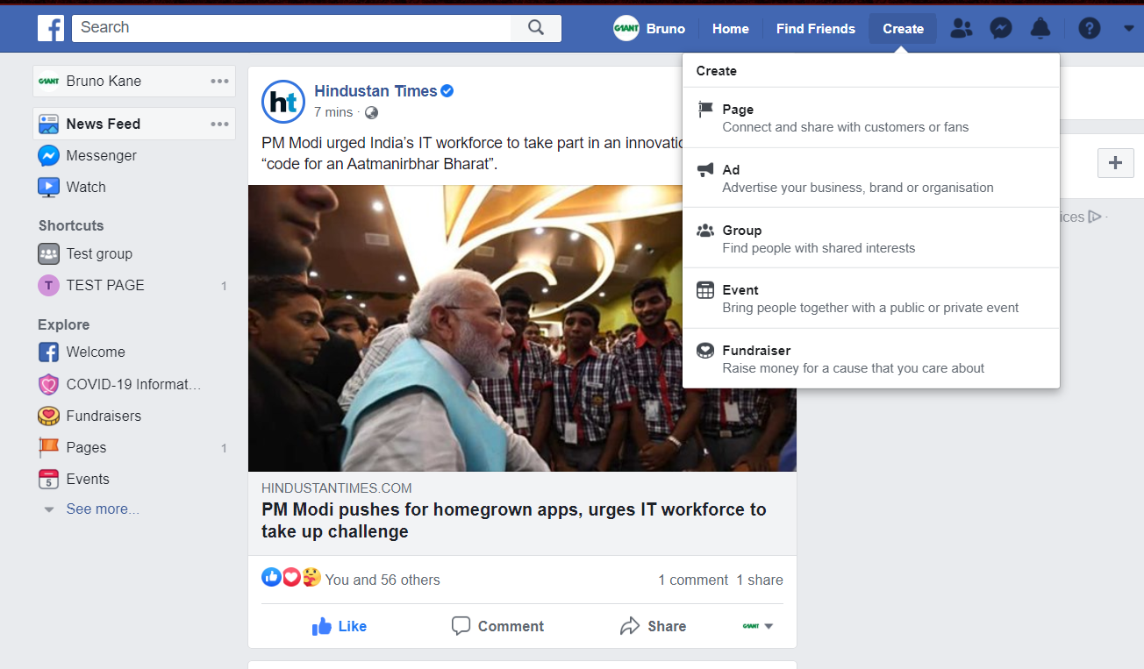

* And can select its privacy and then create it

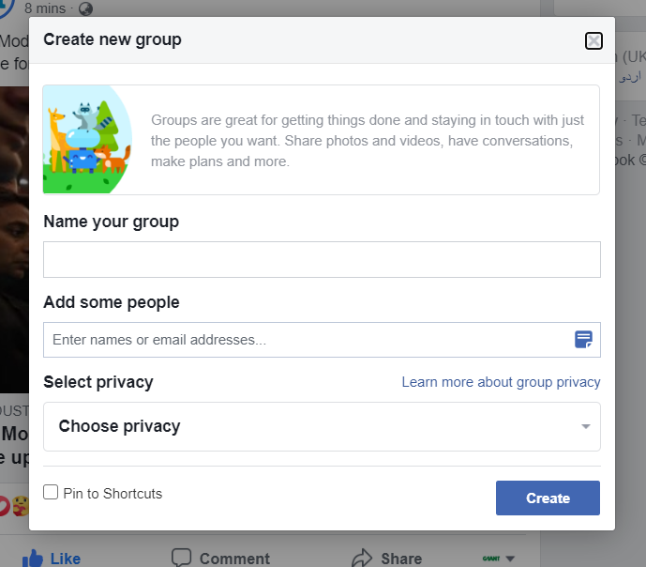

* We can retrieve no of posts from our newsfeed and display its content along with its time and name of uploader in a Dialog Box
* We can display no and name of friends the user have.

LinkedIn

* First we will create two variables to store user’s email and password
* Then we will open linkedin.com on a browser
* Then we will click sign-in button and sign-in by clicking login button

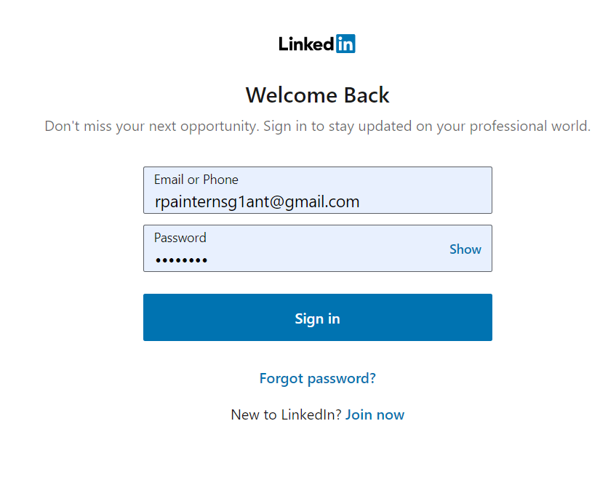

* We can find the people/company and we can open them and follow them on linkedin by taking input from user

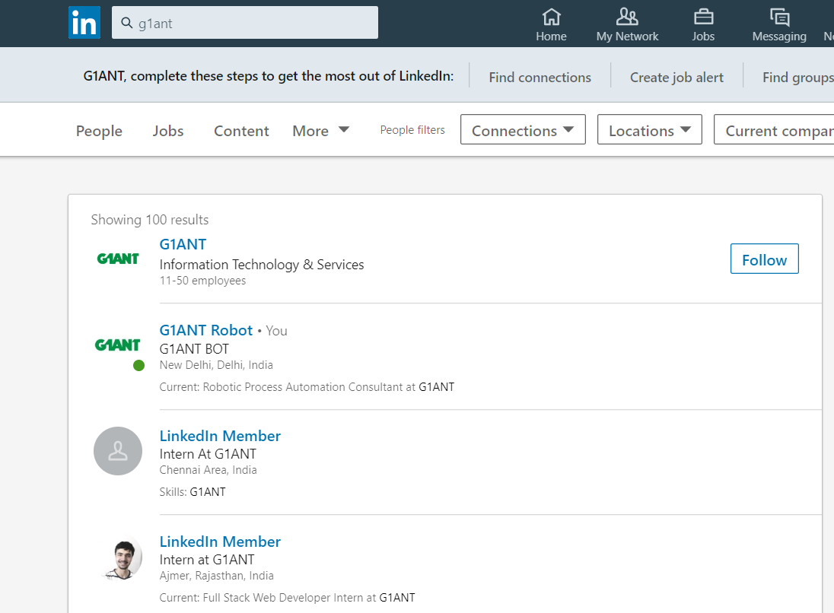

* We can write a post in linkedin by taking a string input from user and share it in the network

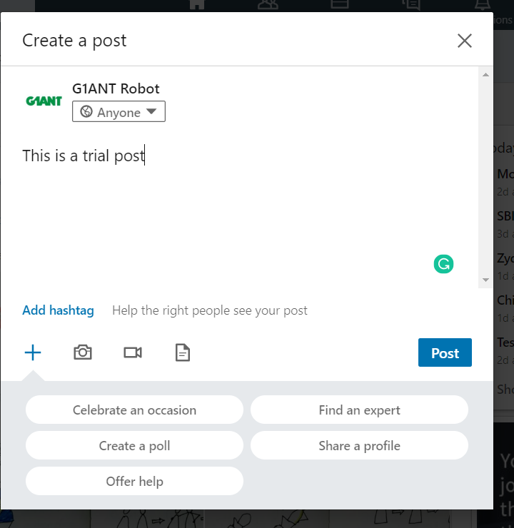

* We can take choice from user to like or comment on the latest post in its feed.

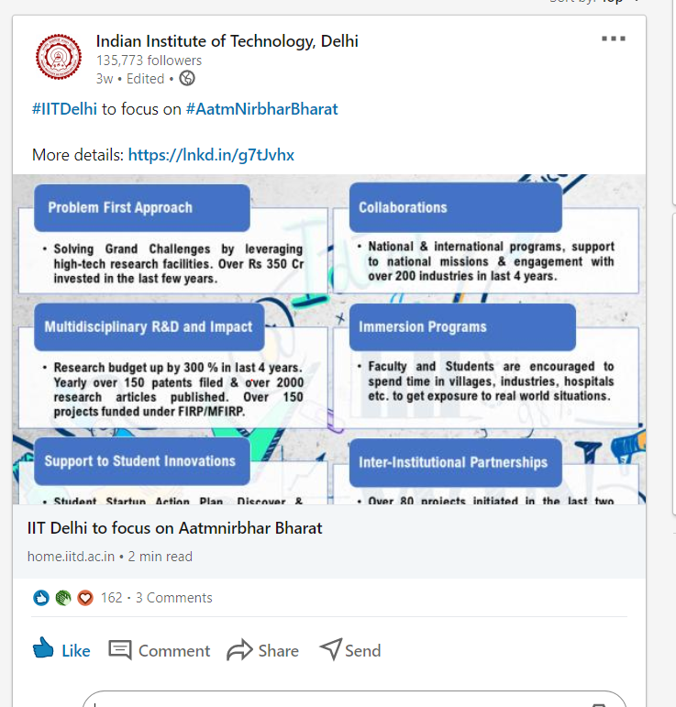

* We can display no of connections user have in a dialog box
* We can display no of people who have viewed their profile
* We can share the latest post of feed if the user allows

Youtube

* We can sign in the user in youtube.com by taking input from user for its login and password

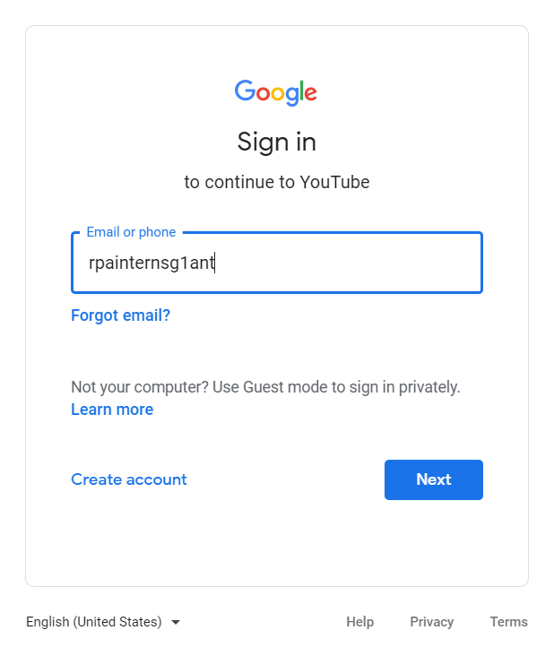

* We can take name of video as input and search it in search bar and then play the result on top of search result

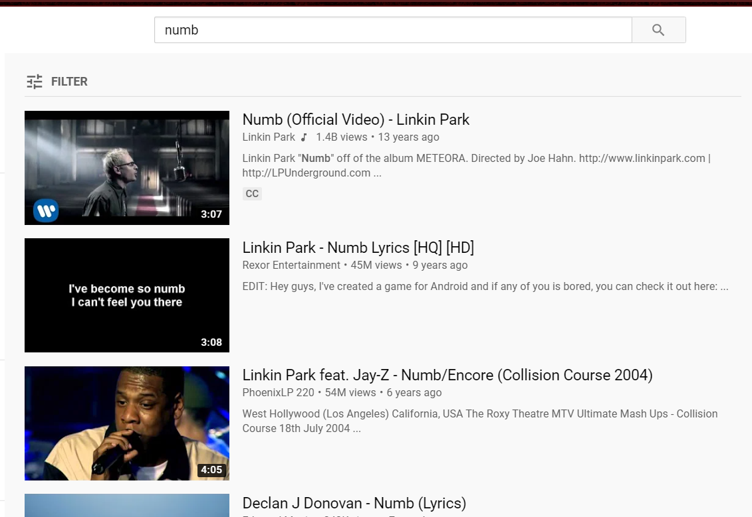

* We can like the playing video if user allows



* We can subscribe the channel which user will give input

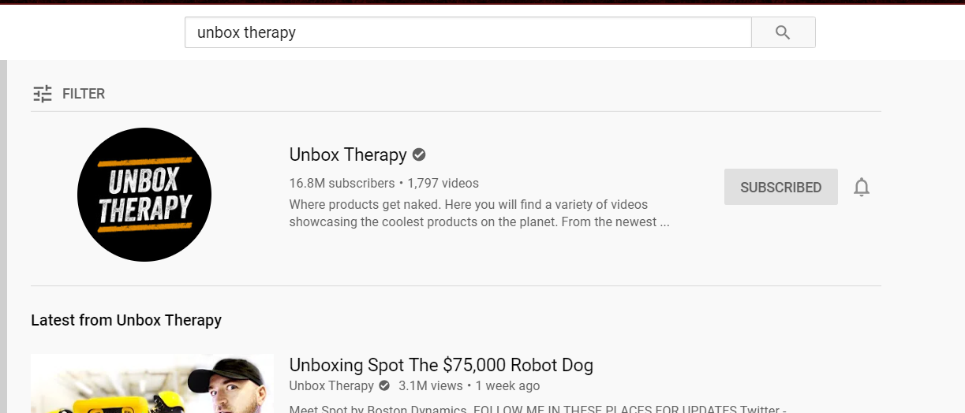

* We can comment in the playing video by taking user’s allowance and input for comment from user

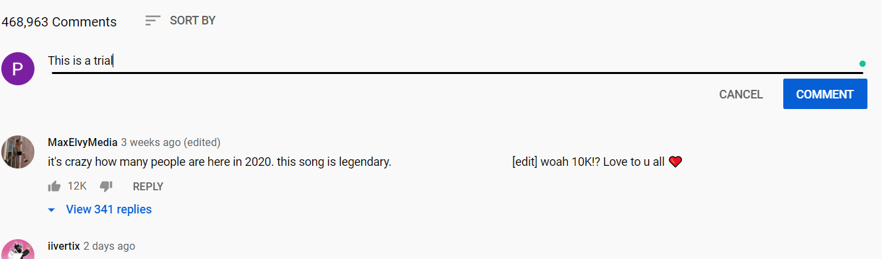

* We can create a channel and upload a video in it
* We can play the latest video of the user’s subscribed channel

Quora

* We can sign in quora.com by taking credentials from user
* We can put up a question by taking question as input from user

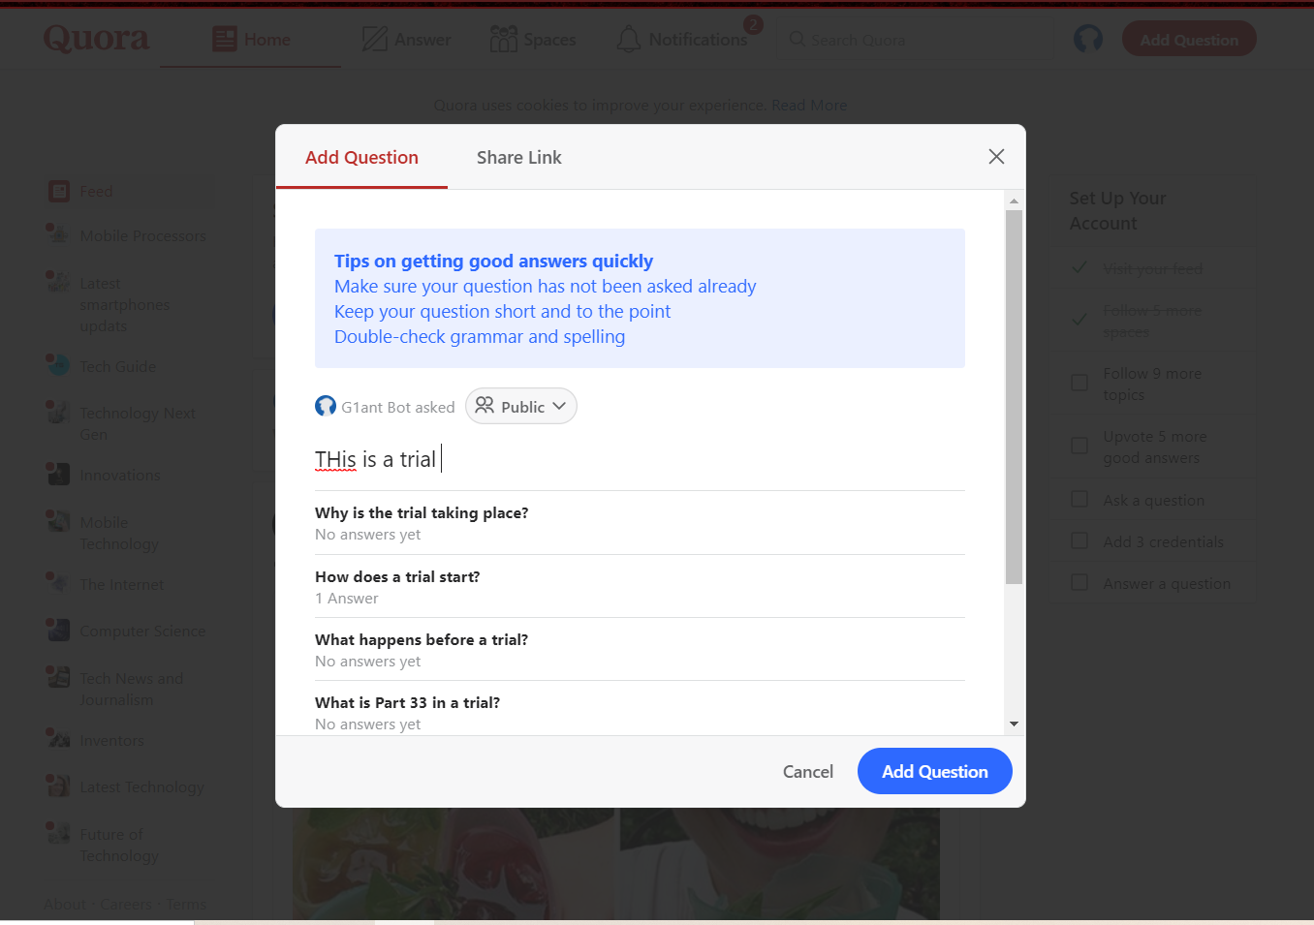

* We can search for question or any space in search bar

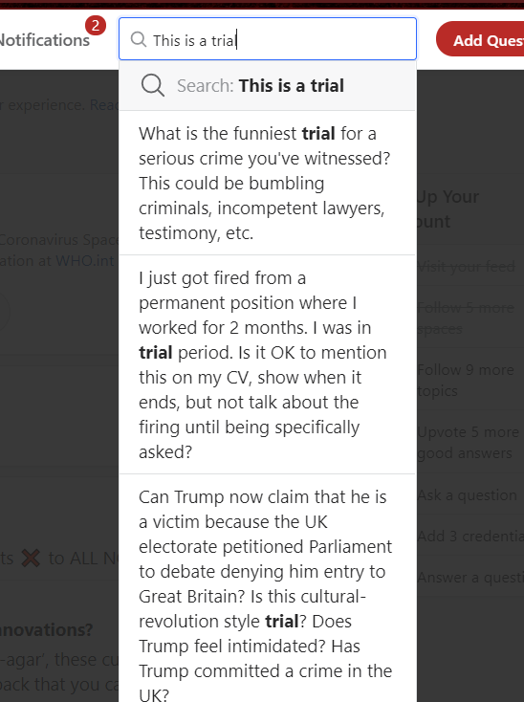

* We can see all spaces we are following

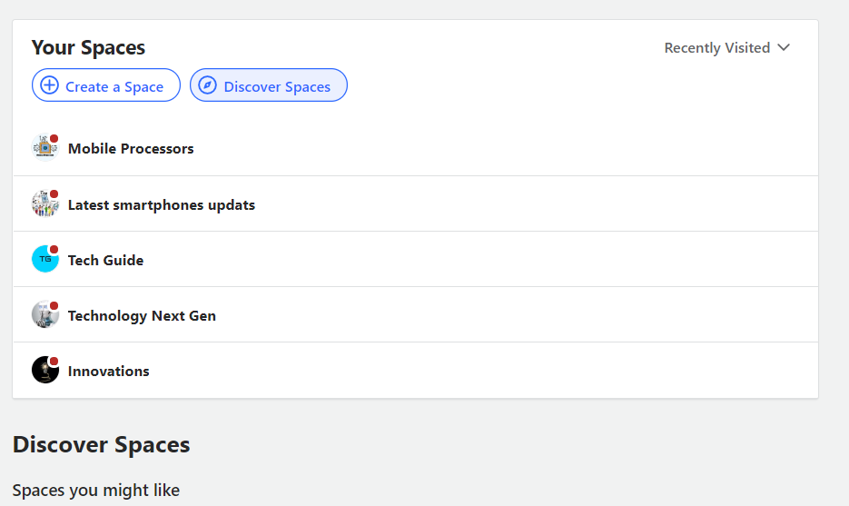

* We can see all notifications of the user

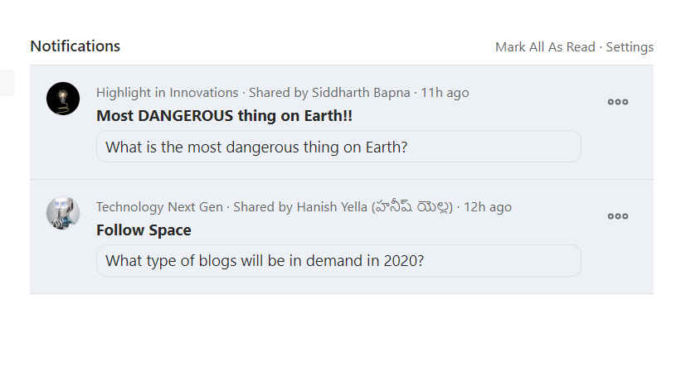

IRCTC

* We can open irctc.com website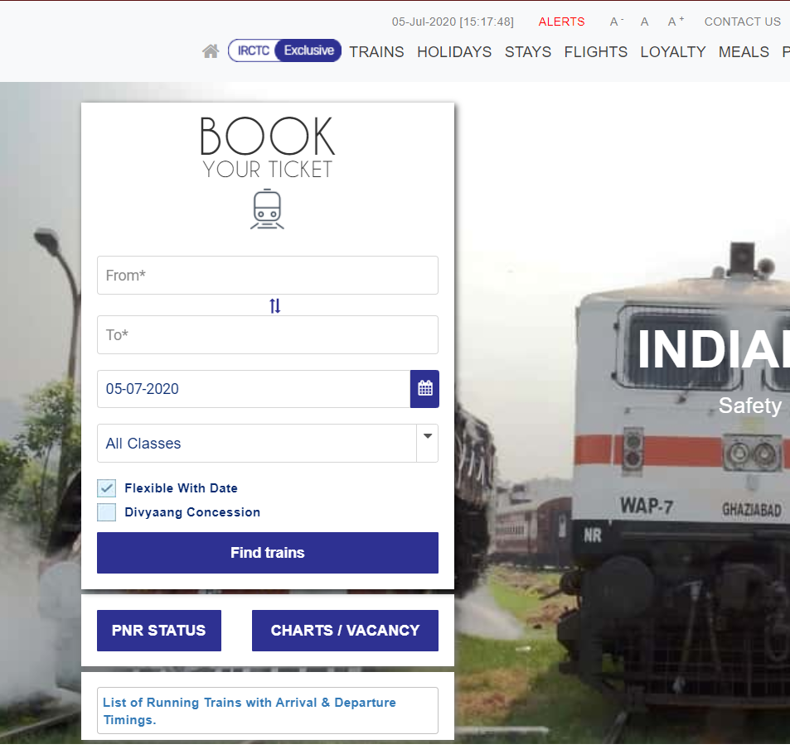
* We can enter origin and destination location by taking input from user

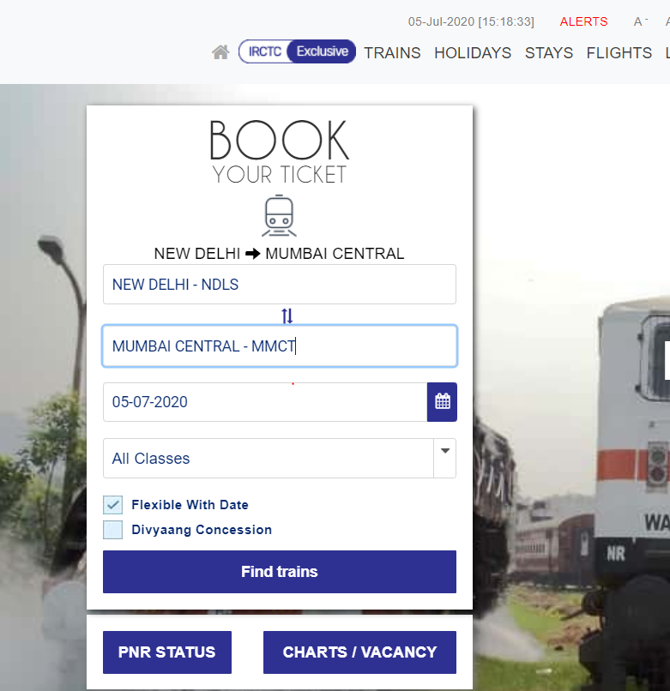

* Also user can enter Date of Travelling and can find trains on that date. Then user can decide which train is suitable for him/her.

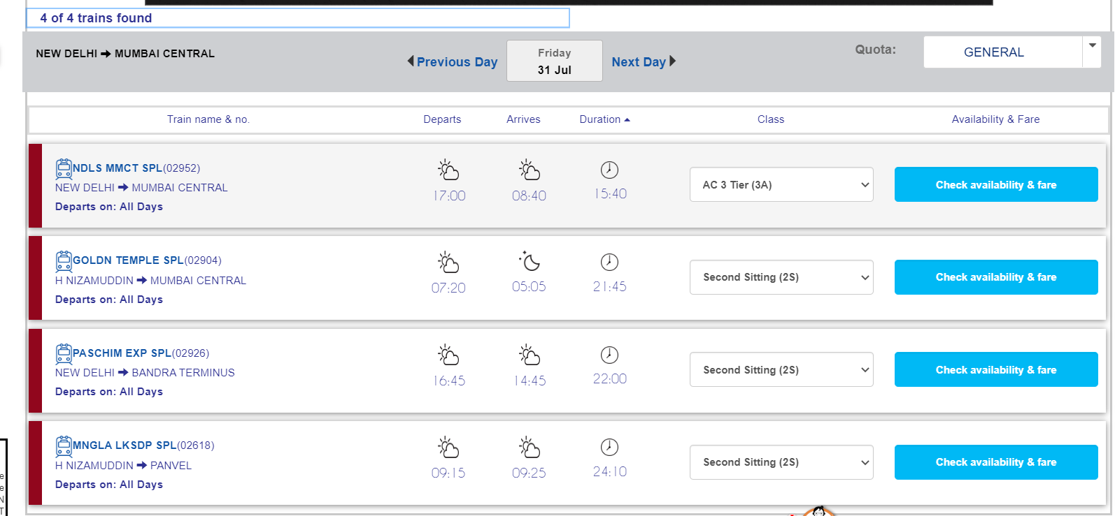

Microsoft Teams

* We can do user sign-in in its website

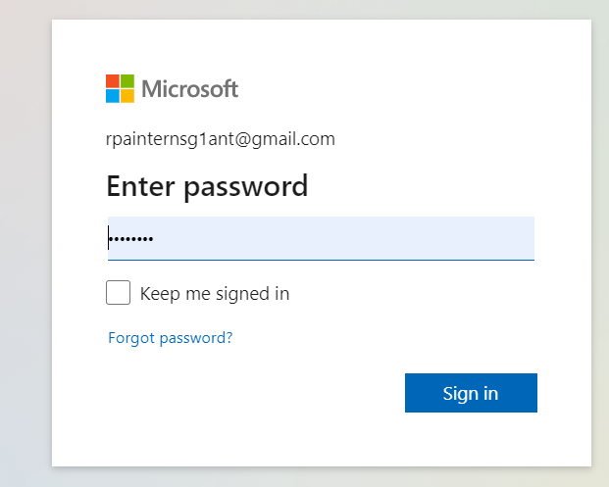

* We can create a team and name it also

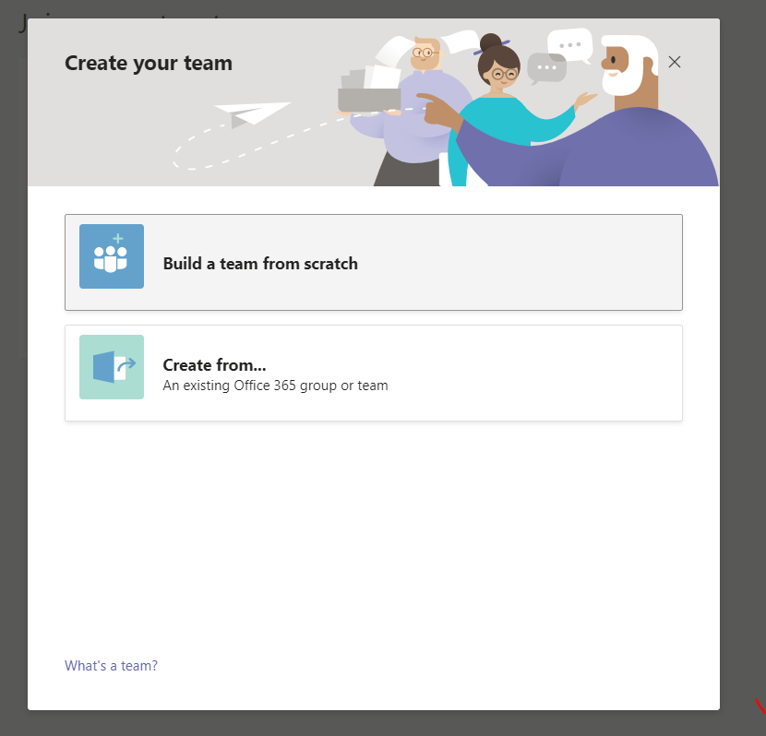

* We can do to chat with a person by taking user’s inputs

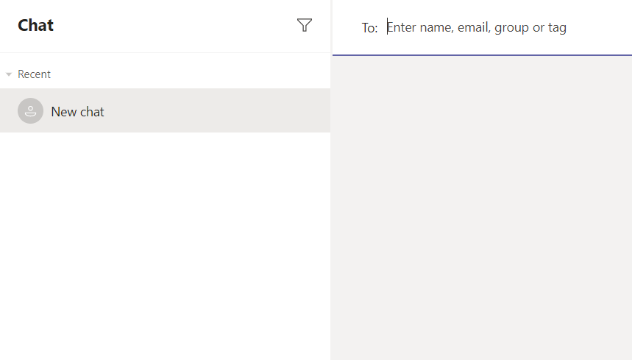

* We can add members in our team

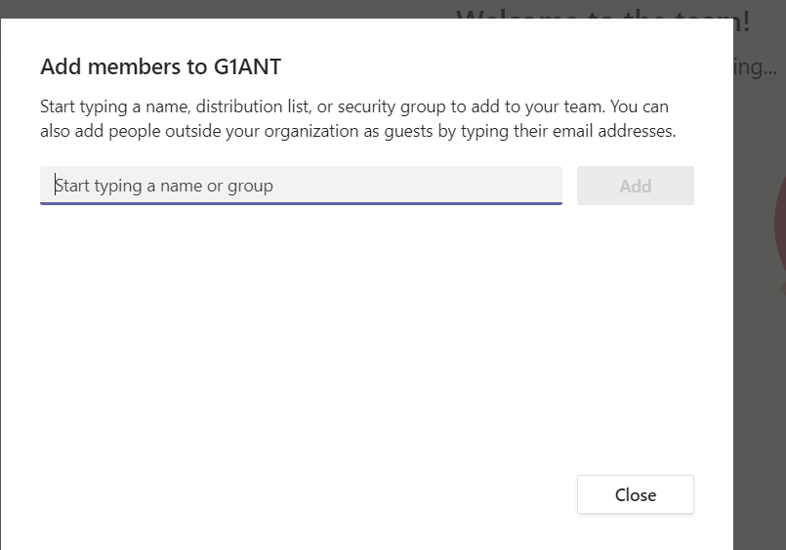

* We can call a person

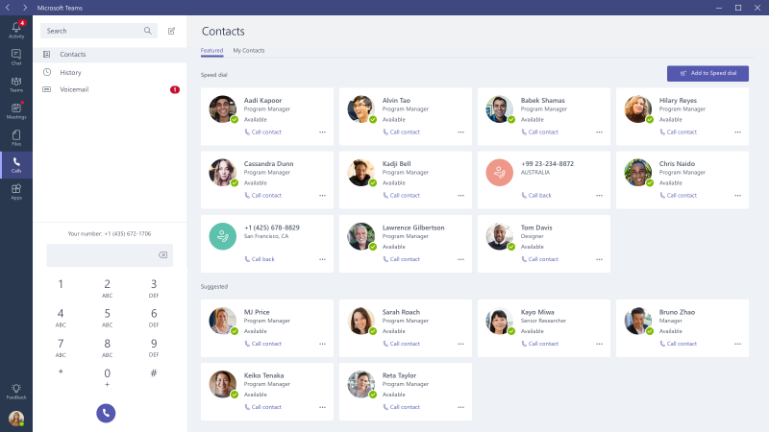

* We can schedule a meeting

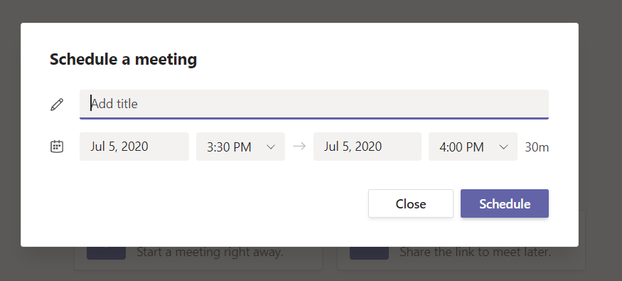

* We can see our activities

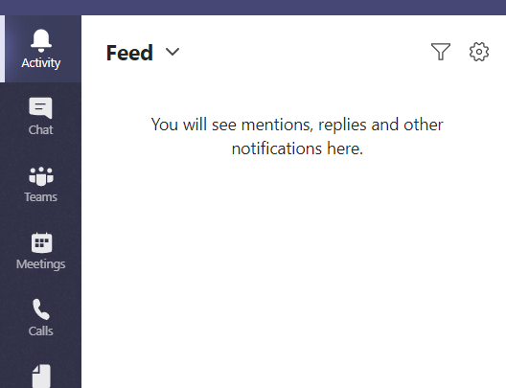

SWIGGY

* We can enter the location and find restaurant in it

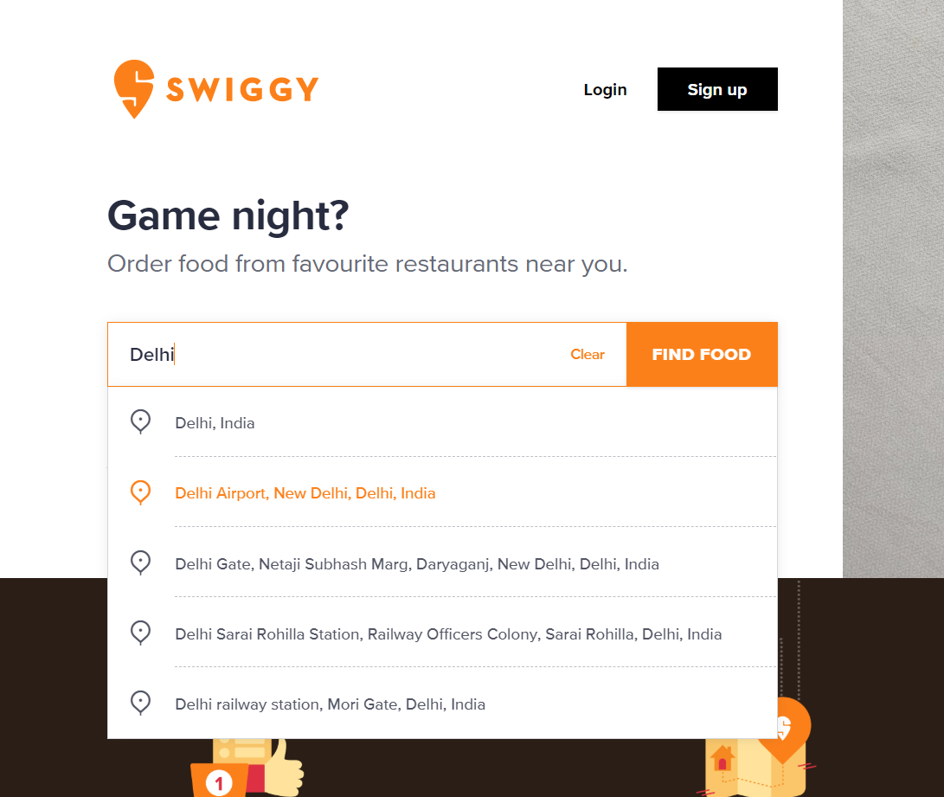

* We can take option from user that it wants pure veg

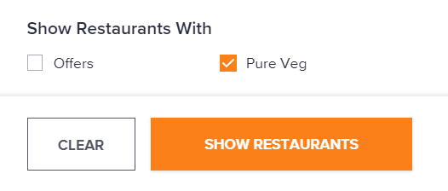

* We can sort the list of restaurants according to Relevance, Cost of Two, Delivery Time, Rating

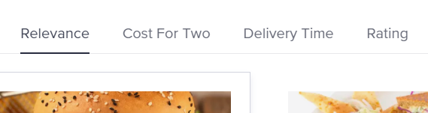

* We can then open the first restarant after taking user’s preference

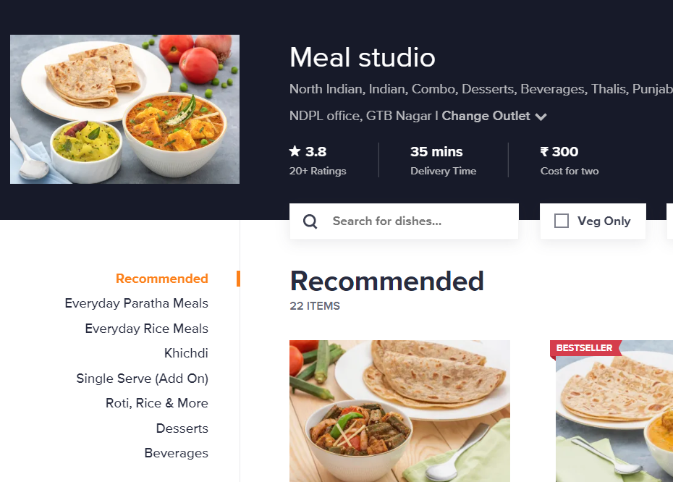

Amazon

* We can sign-in by taking user’s credentials

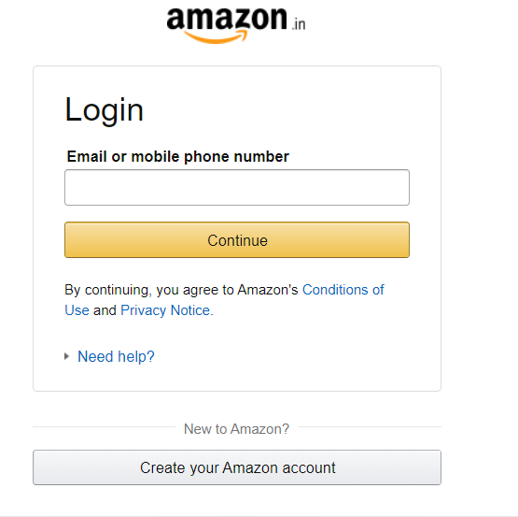

* We can search for item which we will take input from user

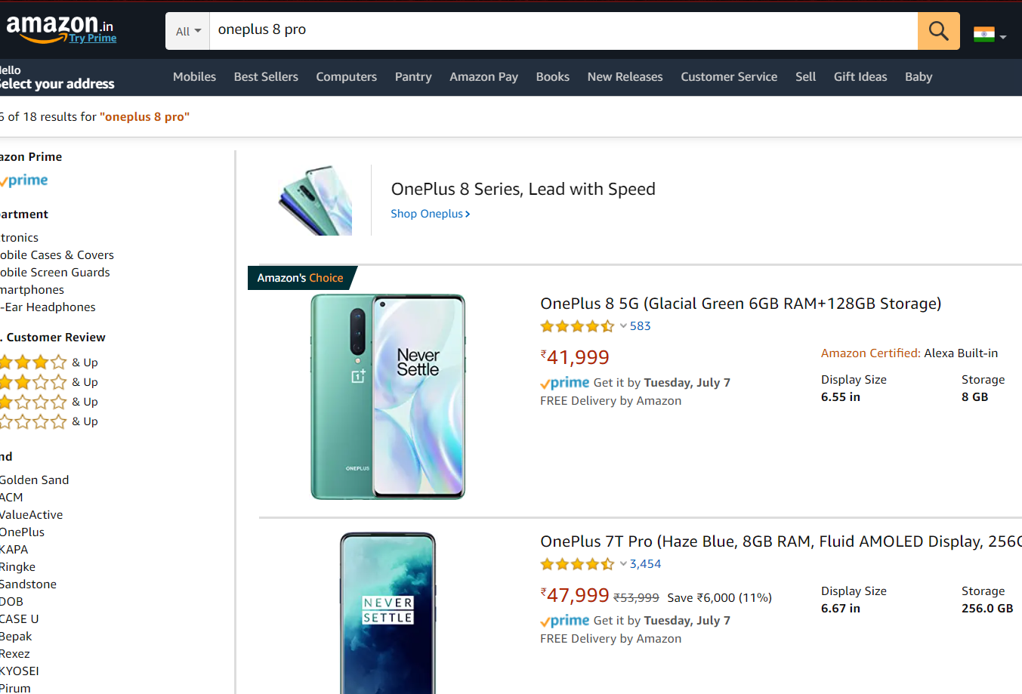

* We can sort them by given features

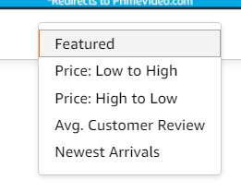

* We can open first product which is satisfied by user’s input

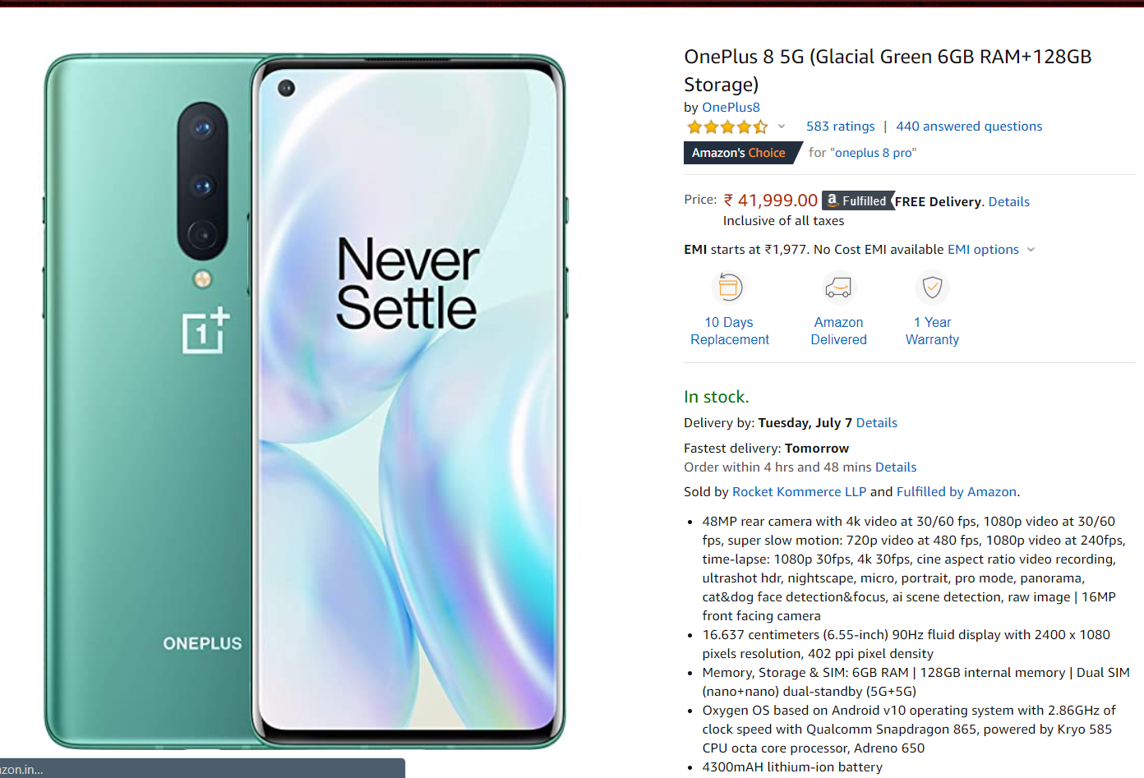

For Mobile App-

Facebook

* We can open Fb and read user’s newsfeed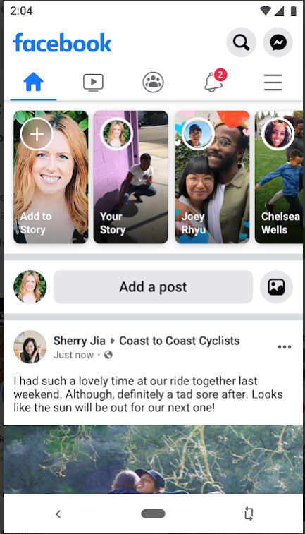
* We can open the user’s profile

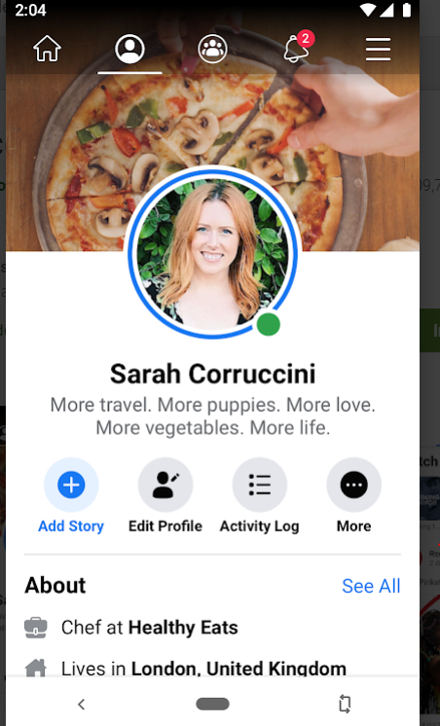

* We can view groups present on Fb

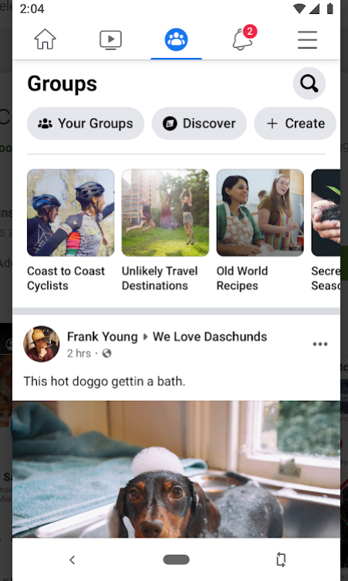

* We can watch trending videos on FB

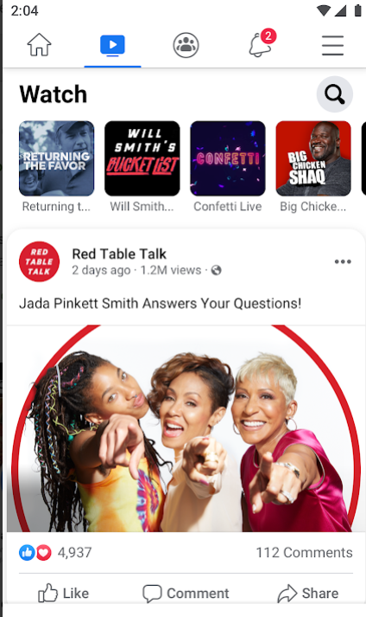

LinkedIn

* We can find new people and connect with them

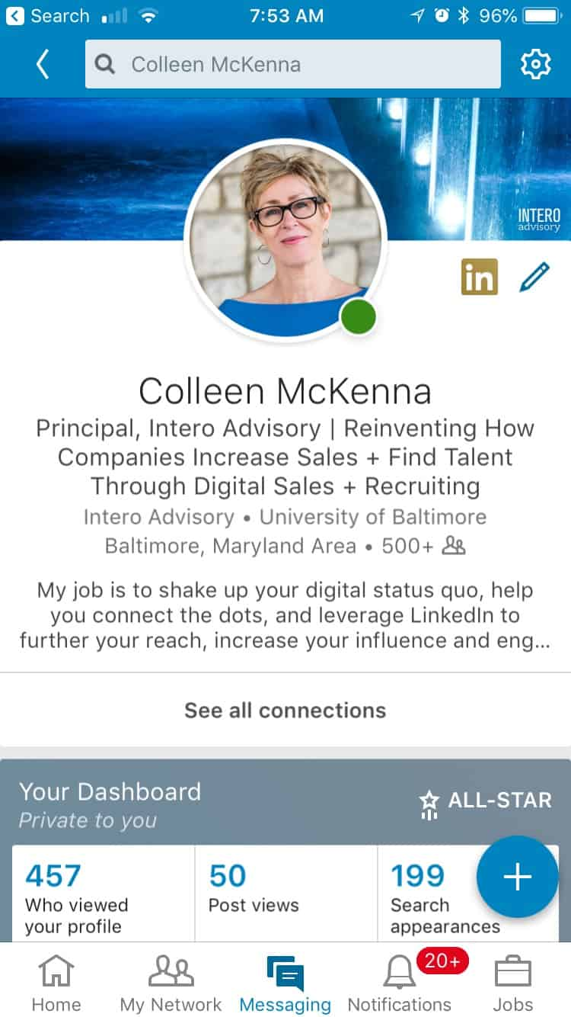

We can open user’s profile

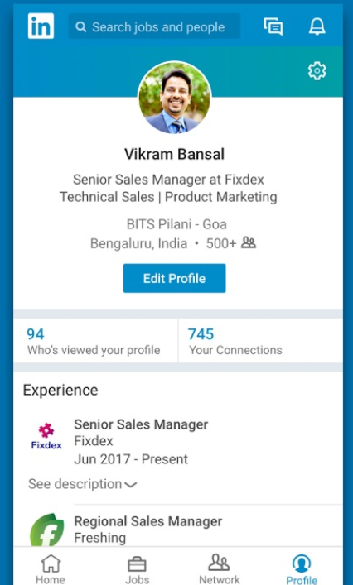

We can scroll in user’s newsfeed



We can find jobs on Linkedin app

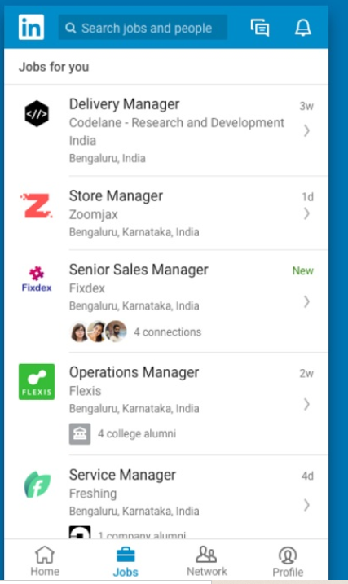

Youtube

We can comment or like a video

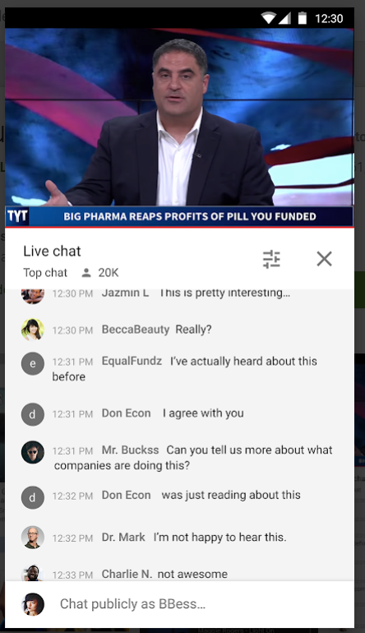

We can subscribe a channel



We can play or create a playlist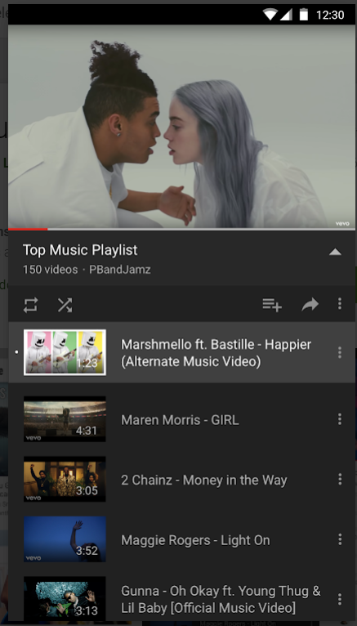

We can play recommended videos on our homepage or open your subscriptions or can view your liked or downloaded videos in Library

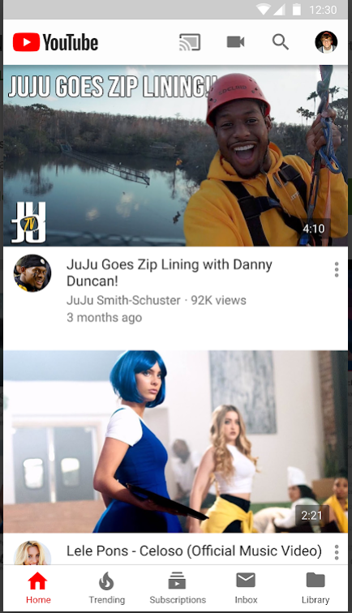

Quora

We can scroll in Feed section of app where questions of user’s interest are present

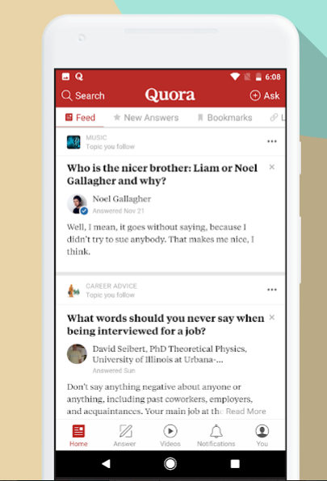

We can ask questions easily on the app

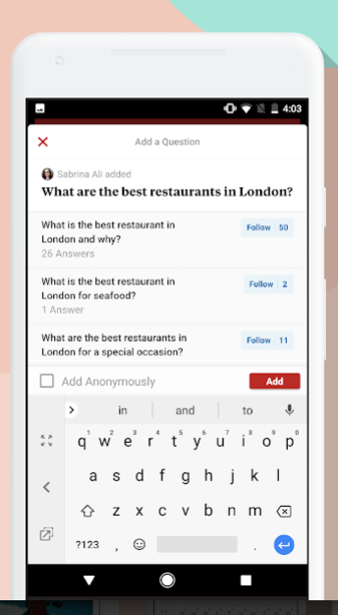

We can join spaces/community of user’s interest

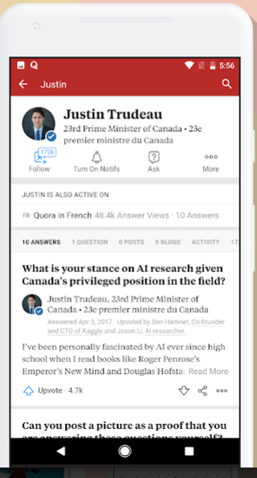

We can answer the questions

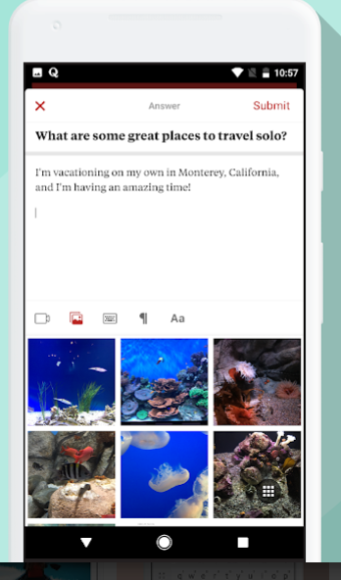

IRCTC

We can sign-in app using user’s credentials

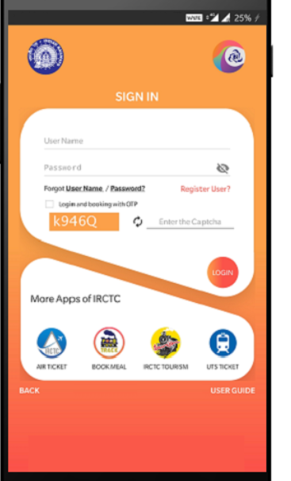

We can plan a journey, view bookings, check pnr,cancel ticket or file tdr using irctc app

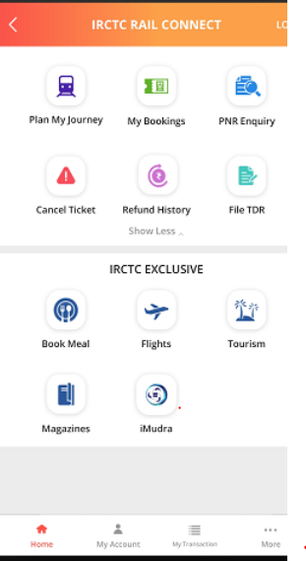

We can book trains on a specified date and location

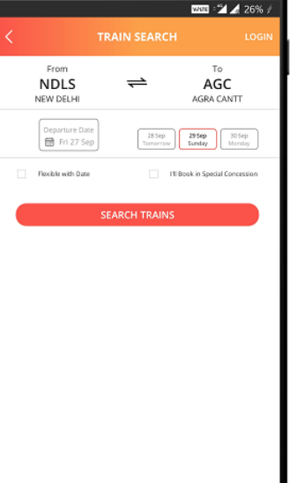

We can check availability of seats in trains of user’s choice

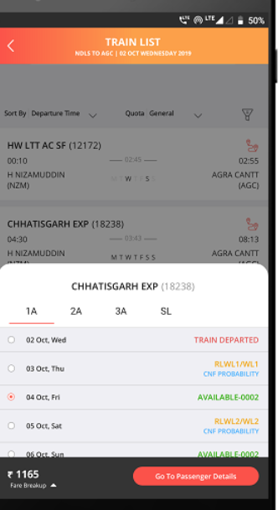

We can then fill passenger’s details and then book the train

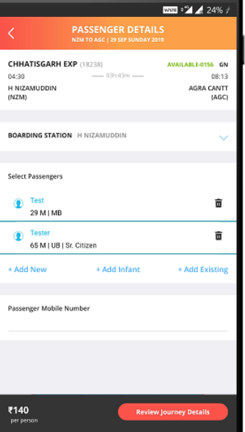

Microsoft Teams

We can chat in a group or with a person

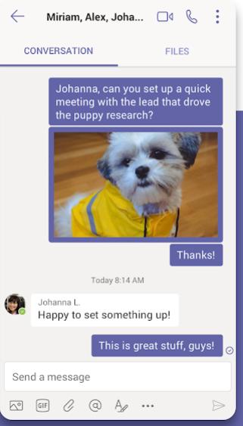

We can do video or voice call with a group or in person



We can join or schedule meetings in the app

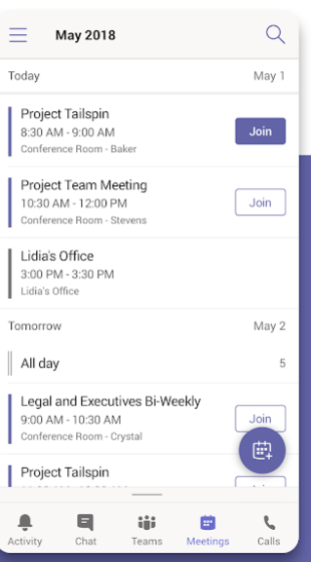

We can access all the files shared in a team

